Higgs boson professional skills

1 Introduction
The Higgs Boson, also known as the Higgs particle (or less formally regarded to as the ‘God particle’ ) is an elementary particle in the standard model of particle physics produced by quantum excitation of the Higgs field. Prior to its discovery, for many decades, the existence of the Higgs field was the last unverified part of the standard model and was widely regarded as ‘the central problem in particle physics’. The Higgs particle is a massive scalar boson whose mass arises from its interactions with the Higgs field, it has 0 spin, positive parity, no electric charge, no colour charge and is very unstable, decaying into other particles almost immediately upon generation.

2 Theory

2.1 The standard model
(Grazzini 2008)
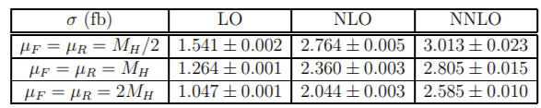
Table 1: Cross sections for ${pp →H+X → e}^{+}e^{-}e^{+}e^{-}+X$ at the LHC when cuts are applied

3 Discovery

3.1 Mass
(Branchina and Messina 2013)
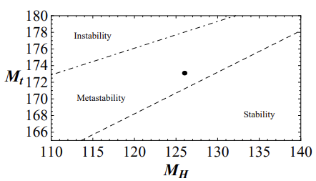
Fig.1 : In this picture we repeat the analysis of [10–12], which is done in the absence of new interactions at the Planck scale. The $M_{H}- M_{T}$ plane is divided in three sectors: absolute stability, metastability and instability regions. The dot indicates $M_{H} \sim 126 GeV$ and $M_{T} \sim 173.1 GeV$.

4 Maths

4.1 maths equation
(Bass, De Roeck and Kado 2021)
  - $$m_{H}^{2}=2λv^{2}$$

Bass, S. D., et al. (2021). "The Higgs boson implications and prospects for future discoveries." Nature Reviews Physics 3(9): 608-624.

Branchina, V. and E. Messina (2013). "Stability, Higgs boson mass, and new physics." Physical review letters 111(24): 241801.

Grazzini, M. (2008). "NNLO predictions for the Higgs boson signal in the H→ WW→ lνlν and H→ ZZ→ 4l decay channels." Journal of High Energy Physics 2008(02): 043.

